EQ – Why did the United States enter WW1?
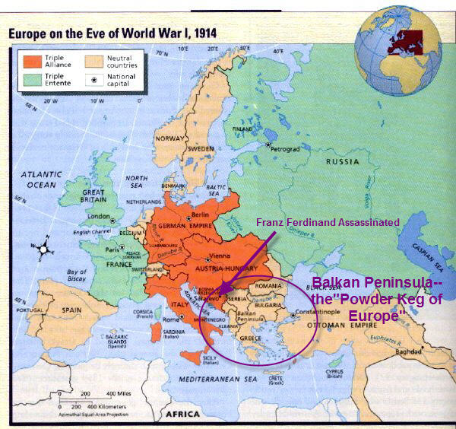 EQ: What was World War I?
- World War: A war involving major nations of the world
- World War I: Was a war between the Allied Powers (Russia, France, British, Italy, United States, Japan, Romania, Serbia, Belgium, Greece, Portugal, Montenegro) and the Central Powers (Germany, Austria-Hungary, Ottoman Empire, Bulgaria)
- World War I took place between 1914 and 1918 and officially begun after the assassination of Austrian Archduke, Franz Ferdinand
- In 1914, the war began when Austria-Hungary declared war on Serbia. During the early years, this war was fought only in Europe
- Most Europeans were caught up in Nationalism
Nationalism- Having pride in & a love of one’s country. Desiring for one’s country to be free from the control of another, and be willing to defend it.
- US President Woodrow Wilson wanted to let other countries handle their own affairs (problems). He chose “isolationism”
Isolationism: Policy in which a nation prefers to remain neutral and let other countries handle their own affairs. US’ goal was to remain neutral; however, they shipped weapons to the Allied powers.
Alliance: An agreement, made between two or more countries to give each other help if it is needed. Once alliances are made, countries have no option and agree to join the war if one of their alliances is attacked.
*Triple Alliance: Germany, Italy, and Austria-Hungary. (Triple alliance ended eventually and became the Central Powers.)
*Triple Entente: Britain, France, and Russia (This was developed in response to the formation of the Triple Alliance and to counter any attacks).
Allied Powers: Great Britain, France, Russia, Italy( switched from Central after war started), and eventually the Unites States.
Central Powers: Germany, Austria-Hungary, Italy (at beginning), Turkey, Bulgaria
EQ: Why did America enter World War I?
Before World War One, the United States followed a policy of isolationism. Isolationism is when a country remains neutral (does not take sides) in world issues and stays out of conflicts.
The United States wanted to stay out of European problems before WW1.
Reasons the United States went to War
- Germany was attacking American ships and sinking them. The American ships were neutral but supplying England with supplies.

The sinking of the Lusitania was another reason why the United States went to war on the side of the Allies. The Americans lost between 114 and 128 citizens
- Germany began using submarines to sink hundreds of US ships suspected of helping Britain.
- May 7, 1915 ocean liner Lusitania was sunk by a torpedo from a German U-boat (submarine). Public outrage in the US helped lead US to enter the war.
- After the sinking of the Lusitania, President Wilson warned Germany not to continue using submarines to ship any ship.
- Feb. 1, 1917 Germany orders submarines to continue attacking any ships suspected of carrying weapons to Allied Powers.

The Zimmerman Note: German Foreign Secretary Zimmerman sent a telegram (note) to the Ambassador in Mexico stating that if Mexico helped Germany defeat the US, then Germany will redeliver TX, NM, and AZ to them (territories originally taken from Mexico by the US).
- The US learns of the Zimmermann telegram and publishes it in the American Press, which fuels the hostility!
**April 6, 1917 US declares war! We were on the Allied Powers side.
`
Before World War One, the United States followed a policy of isolationism. Isolationism is when a country remains neutral in world issues and stays out of conflicts.
The United States wanted to stay out of European problems before WW1.

Reasons the United States went to War
- Germany was attacking American ships and sinking them. The American ships were neutral but supplying England with supplies.

- The sinking of the Lusitania was another reason why the United States went to war on the side of the Allies. The Americans lost between 114 and 128 citizens.

