Step by Step: Multiplying Fractions by Fractions using the Area Model
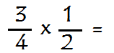
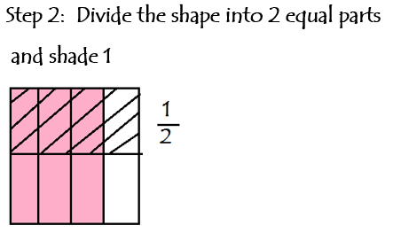
Step 1: Divide the shape into 4 equal
parts and shade 3
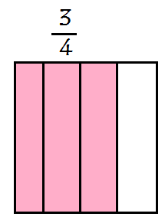
Step 4: Check
Remember: Multiply straight across

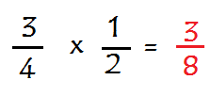

Perfect! The model and check are the same.
Step 3: Count the area that is double
shaded. This is the numerator and the
denominator will be the total parts of
the shape.
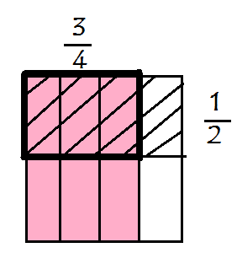
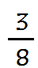
Total number of equal parts is 8

