World War 1 was a military conflict lasting from 1914 to 1918 which involved nearly all the biggest powers of the world. It involved two opposing alliances - the Allies and the Central Powers. An alliance is an agreement made between two or more countries to give each other help if it is needed. Once an alliance is made, countries have no choice but to go to war if one of their alliances is attacked. Some of the countries of the Allies included Russia, France, Britain, Italy, United States, Serbia, Belgium, Greece, Portugal and Montenegro. The countries of the Central Powers included Germany, Austria-Hungary, Turkey and Bulgaria.
Reasons for War
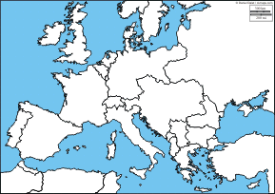

Task 1: List the Central and Allied Powers and label where the countries are on the map. You do not have to label the United States.

World War 1 began on 28 June 1914 by the assassination of the Archduke Franz Ferdinand of Austria and his pregnant wife Sophie. Archduke Franz Ferdinand of Austria was heir to the throne of Austria and Hungary. The assassination was planned by a Serbian terrorist group, called The Black Hand and the man who shot Franz Ferdinand and his wife was a Bosnian revolutionary named Gavrilo Princip.
When the war started, most Europeans were caught up in nationalism. Nationalism is having pride and love of one’s country. There is a strong feeling for one’s country to be free from the control of another country, and be willing to defend it.
.
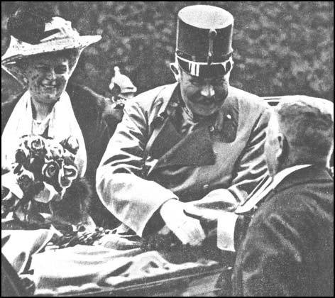
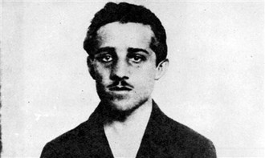
Victims: Archduke Franz Ferdinand of Austria and his wife Sophie
Suspect: Gavrilo Princip of The Black Hand

Causes for War:
a) A tangle of alliances made between countries, to maintain a balance power in Europe, which brought about the scale of the conflict
b) Austria-Hungary took over Bosnia in 1909 angering Serbia.
c) Countries were building their military forces, arms and battleships.
Other names for World War 1
- The War to End All Wars
- The War of the Nations
- The Great War
Task 2: After reading all of the information provided, complete the “Operation Closed Eyes” report. Be sure to include your thoughts and questions for the President Wilson.
Operation Closed Eyes
Intelligence Collected

My Thoughts

5. In 1915, the British passenger sip Lusitania was sunk by a German submarine. In all, 1,195 passengers, including 128 Americans, lost their lives. Americans were outraged and put pressure on the U.S. government to enter the war. President Woodrow Wilson wanted a peaceful end to the war, but in 1917, when the Germans announced that their submarines would sink any ship that approached Britain, Wilson declared that America would enter the war and restore peace to Europe. The United States entered the war on April 6, 1917.
6. 65 million troops were mobilized during during the war, 8 million troops died and 21 million troops were wounded. 58,000 British soldiers were lost on the first day at the Battle of the Somme. Chemical weapons were first used in World War I. The chemical was mustard gas.
7. The U.S. was in the war in actual combat for only seven and a half months during which time 116,000 were killed and 204,000 were wounded. In the Battle of Verdun in 1916, there were over a million casualties in ten months.
8. By 1918, German citizens were striking and demonstrating against the war. The British navy blocked German ports, which meant that thousands of Germans were starving and the economy was collapsing. Then the German navy suffered a major mutiny. After German Emperor Kaiser Wilhelm II abdicated on November 9th, 1918, the leaders of both sides met at Compiegne, France. The peace armistice was signed on November 11th. By the end of the war four empires — the Russian, the Ottoman, the German, and the Austro-Hungarian had collapsed because of the war.
9. In 1919, The Treaty of Versailles officially ended the War. The Treaty required that Germany accept full responsibility for causing the war; make reparations to some Allied countries; surrender some of its territory to surrounding countries; surrender its African colonies; and limit the size of its military. The Treaty also established the League of Nations to prevent future wars. The League of Nations helped Europe rebuild and fifty-three nations joined by 1923. But the U.S. Senate refused to let the United States join the League of Nations, and as a result, President Wilson, who had established the League, suffered a nervous collapse and spent the rest of his term as an invalid.
10. Germany joined the League of Nations in 1926, but many Germans were very resentful of the Treaty of Versailles. Germany and Japan withdrew from the League of Nations in 1933. Italy withdrew three years later. The League of Nations was unable to stop German, Italian, and Japanese from expanding their power and taking over smaller countries. Many believe World War I never really ended, and that World War II never would have happened if not for World War I.

