Modeling Decimal by Decimal Division
Step by Step
1.8 ÷ .3 = _____
Step 1:
Mark off 1.8 on the grids
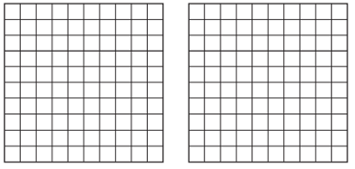
1 .8
Step 2:
Shade groups of .3
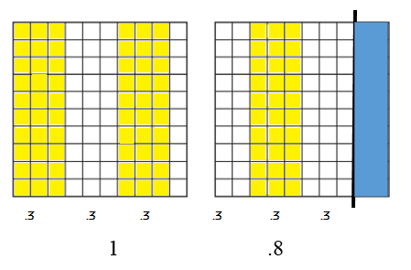
Step 3: Count the number of 3 tenths groups that appear
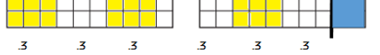
.3 appears 6 times SO 1.8 ÷ .3 = 6

