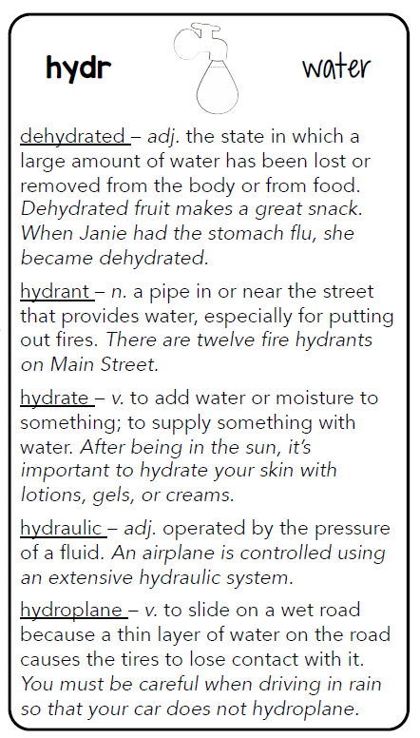

**Aqua – water**

Aquarium – n. a container of water for animals.

Aquatic – adj. having to do with water.

*A shark is an aquatic animal because it lives in the ocean.*

Aqueduct – a pipe or channel that leads to water to certain places.

*The farmers built an aqueduct over the valley to move water to their fields.*



Aqueduct



hydroplane

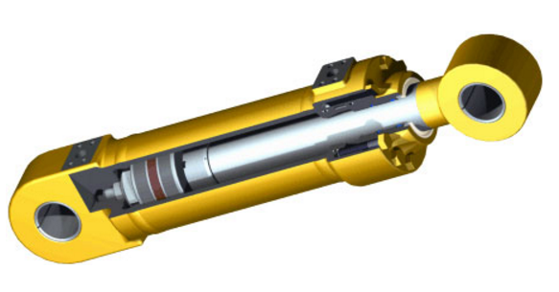

hydraulic