[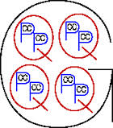](http://www.google.com/url?sa=i&rct=j&q=&esrc=s&frm=1&source=images&cd=&cad=rja&uact=8&docid=vBnv_8YpeDPs_M&tbnid=zKHtzExJtXvZXM:&ved=0CAYQjRw&url=http%3A%2F%2Fwww.teachnet.com%2Flesson%2Fmath%2Funits052499.html&ei=TsspU9mqItPOkQfFsYCgDw&bvm=bv.62922401,d.eW0&psig=AFQjCNGo1MiLHV4gVFFp62G0WhMJHjmETg&ust=1395334346144819)